“ChatCrypt - Chat Application with Encryption”
A
Project Report
submitted in partial fulfillment of the
requirements for the award of the degree of

BACHELOR OF TECHNOLOGY
in
COMPUTER SCIENCE & ENGINEERING

by

Name | Roll No.
Abhinav | 2142220217
Pradumn Pandey | 2142220217
Shrey Varma | 2142220217
Soham Pahari | 2142221173

under the guidance of
Dr. Sandeep Chand Kumain


School of Computer Science
University of Petroleum & Energy Studies
Bidholi, Via Prem Nagar, Dehradun, Uttarakhand
December – 2024

CANDIDATE’S DECLARATION

We hereby certify that the project work entitled “ChatCrypt – Chat Application with Encryption” in partial fulfilment of the requirements for the award of the Degree of BACHELOR OF TECHNOLOGY in COMPUTER SCIENCE AND ENGINEERING with specialization in DATA SCIENCE and submitted to the Department of Systemics, School of Computer Science, University of Petroleum & Energy Studies, Dehradun, is an authentic record of my/ our work carried out during a period from August, 2024 to December, 2024 under the supervision of
Dr. Sandeep Chand Kumain.

The matter presented in this project has not been submitted by me/ us for the award of any other degree of this or any other University.

Abhinav | 2142220217
Pradumn Pandey | 2142220217
Shrey Varma | 2142220217
Soham Pahari | 2142221173

This is to certify that the above statement made by the candidate is correct to the best of my knowledge.

Date: _____________ Dr Sandeep C Kumain
Project Guide

ACKNOWLEDGEMENT

We wish to express our deep gratitude to our guide Dr. Sandeep Chand Kumain, for all advice, encouragement and constant support he has given us throughout our project work. This work would not have been possible without his support and valuable suggestions.
We sincerely thank to our respected Name of HoD, Head Department of _____________, for his great support in doing our project in ChatCrypt.
We are also grateful to Dean SoCS UPES for giving us the necessary facilities to carry out our project work successfully. We also thanks to our Course Coordinator, Dr. Chhotelal Kumar and our Activity Coordinator Dr Virender Kadyan for providing timely support and information during the completion of this project.
We would like to thank all our friends for their help and constructive criticism during our project work. Finally, we have no words to express our sincere gratitude to our parents who have shown us this world and for every support they have given us.

Name | Soham | Shrey | Pradumn | Abhinav
Roll No. | 2142221173 | 2142220217 | 2142220217 | 2142220217

ABSTRACT

This project focuses on developing an online chat application, ChatCrypt, that facilitates real-time communication while ensuring robust data security through advanced encryption techniques. Designed for both personal and professional use, the application integrates intuitive features like instant messaging, seamless group collaboration, and visual feedback for an enhanced user experience. The platform’s secure messaging system leverages Spring Boot with HTTPS GET/POST methods for real-time messaging, ensuring efficient and reliable exchanges between users. Key features include encrypted message transmission, responsive interfaces, and dynamic notifications. By addressing privacy concerns and usability, ChatCrypt aims to establish itself as a secure, user-friendly communication platform.

TABLE OF CONTENTS

S.No. Contents Page No

- Introduction 1
  - History 2
  - Requirement Analysis 3
  - Main Objective 4
  - Sub Objectives 4
  - Pert Chart Legend 5
- System Analysis 6
  - Existing System 6
  - Motivations 7
  - Proposed System 7
  - Modules 8
2.4.1. Object Detection and Collision Avoidance 8
2.4.2. Servo Motor Control 8
2.4.3. Path Tracking 9
- Design 10
  - Modelling in Robots 10
3.1.1. Behaviour-based Robotics 10
3.1.2. Use Case model for Requirement Analysis 11
3.1.3. The design model 12
3.1.4. Object and Class Design 13
3.1.5. State Transition 14
3.1.6. Activity Diagram 17
- BOE-BOT 18
  - Boe-Bot Overview 18
  - Basic Stamp –Boe-Bot’s Brain 19
4.2.1.Technical Specifications 20
4.2.2 Features 21
4.2.3 Architecture-memory organization 23
4.3. Programming the BOE-BOT 24
4.3.1. Quick Start Guide 24
4.4.Boe-Bot’s Servo Motors 29
4.5.Infrared Sensors 30
4.6.Ultrasonic Sensors 32
- Implementation 34
  - Path tracing using a Cartesian Co-ordinate System 34
  - Scenarios 36
  - Algorithms 39
5.3.1.Scenario -1 Co-ordinate Based Seeking 39
5.3.2.Scenario -2 Lookup Based Seeking 40
5.3.3.Scenario -3 Serpentine Scanning
- Output screens 44
- Limitations and Future Enhancements 68
- Conclusion 69
Appendix A: BASIC Stamp and Carrier Board Components 70
and Features
Appendix B: Resistor Color Codes 72
Appendix C: Breadboarding Rules 73
References 76

LIST OF FIGURES

S.No. Figure Page No

- Chapter 1
Fig. 1.1 Pert Chart 5

- Chapter 2
Fig. 2.1 Servo Motors Overview 8

- Chapter 3
Fig. 3.1 Use Cases Model for the System 11
Fig. 3.2 Sequence Diagram 12
Fig. 3.3 Class Diagram 13
Fig. 3.4 State Transition Diagram for the detecting behavior 14
Fig. 3.5 State Transition Diagram for the finding path behavior 15
Fig. 3.6 State Transition Diagram for the obstacle avoidance behavior 15
Fig. 3.7 State Transition Diagram for the restoring path behavior 16
Fig. 3.8 Activity Diagram for the system 17
- Chapter 4
Fig. 4.1 Boe-Bot 18
Fig. 4.2. Basic Stamp® 2 Module on a Boe-Bot Robot 20
Fig. 4.3 Basic Stamp 2 21
Fig. 4.4 Basic Stamp 2 OEM 22
Fig. 4.5 BS1-IC,BS1 Carrier Board, and BS1 Serial Adapter 25
Fig. 4.6 BS2-IC and Board of Education 26
Fig. 4.7 Test your PC connection to the BASIC Stamp 27
Fig. 4.8 Entering the $STAMP and $PBASIC directives 27
from the toolbar

Fig. 4.9 To run the program,you may use the task bar menu 28
Or the Run icon
Fig. 4.10 Debug Terminal displaying Program Output 29
Fig. 4.11 Parallax Continuous Rotation Servos 30
Fig. 4.12 Object Detection with IR Headlights 31
Fig. 4.13 Infrared Module Parts 32
Fig. 4.14 Ultrasonic Distance Sensor 32
5. Chapter 5
Fig. 5.1 Path tracing without obstacles 35
Fig. 5.2 Path tracing with obstacles 36
Fig. 5.3 Scenario-1 Co-ordinate based seeking 37
Fig. 5.4 Scenario-2 Lookup Based Seeking 38
Fig. 5.5 Scenario-3 Serpentine Scanning 38
- Chapter 6
Fig. 6.1 The Cartesian Co-ordinate System 44
Fig. 6.2 Scenario-1 without obstacles (1) 45
Fig. 6.3 Scenario-1 without obstacles (2) 46
Fig. 6.4 Scenario-1 without obstacles (3) 47
Fig. 6.5 Scenario-1 without obstacles (4) 48
Fig. 6.6 Scenario-1 without obstacles (5) 49
Fig. 6.7 Scenario-1 without obstacles (6) 50
Fig. 6.8 Scenario-1 with obstacles (1) 51
Fig. 6.9 Scenario-1 with obstacles (2) 52
Fig. 6.10 Scenario-1 with obstacles (3) 53
Fig. 6.11 Scenario-1 with obstacles (4) 54
Fig. 6.12 Scenario-1 with obstacles (5) 55
Fig. 6.13 Scenario-1 with obstacles (6) 56
Fig. 6.14 Scenario-1 with obstacles (7) 57
Fig. 6.15 Scenario-1 with obstacles (8) 58
Fig. 6.16 Scenario-2 without obstacles(1) 59
Fig. 6.16 Scenario-2 without obstacles(1) 59
Fig. 6.17 Scenario-2 without obstacles(2) 60
Fig. 6.18 Scenario-2 without obstacles(3) 61
Fig. 6.19 Scenario-2 without obstacles(4) 62
Fig. 6.20 Scenario-2 without obstacles(5) 63
Fig. 6.21 Scenario-3(1) 64
Fig. 6.22 Scenario-3(2) 65
Fig. 6.23 Scenario-3(3) 66
Fig. 6.24 Scenario-3(4) 67
Appendix-A :BASIC Stamp and Carrier Board
Components and Features
Fig. A-1 BASIC Stamp® 2 Microcontroller Module 70
Components and Their functions
Fig. A-2 Board of Education® Rev C Carrier Board 71
Appendix-B Resistor Color Codes
Fig. B-1 Resistor Color codes 72
Appendix-C Breadboarding Rules
Fig. C-1 Prototyping Area 73
Fig. C-2 Part Drawings and Schematic Symbols 74
Fig. C-3 Example Schematic and Wiring Diagrams 75

LIST OF TABLES

S.No. Table Page No

- Chapter 4
Table 4.1 BS2 Features 21
Table 4.2 Basic Stamp 2 Pin Descriptions 23
Table 4.3 RAM organization for all BS2 models 24

- Appendix B:Resistor Color Codes
Table B-1 Resistor Color code values 72

1. Introduction

Digital communication platforms have become indispensable in modern life, enabling users to connect instantly across personal and professional domains. However, many existing chat applications struggle to balance security and usability, leaving users vulnerable to unauthorized data access. ChatCrypt is designed to address these challenges, providing a secure and responsive environment for real-time communication. Leveraging HTTPS GET/POST methods and Spring Boot, the application ensures instant message delivery while safeguarding user data with advanced encryption. With features like group chats, visual cues, and intuitive controls, ChatCrypt enhances the user experience, fostering seamless and secure interactions.

2. Problem Statement
In an era of digital dependency, users often face difficulties finding platforms that prioritize both privacy and efficiency in communication. Existing chat applications frequently fall short in terms of user-friendly interfaces and robust encryption protocols, leaving conversations exposed to potential threats. This project aims to bridge these gaps by creating a secure, real-time messaging platform that enhances collaboration while ensuring data protection. ChatCrypt addresses the dual challenges of usability and security, providing a solution tailored to modern communication needs.

3. Literature Review

3.1 Development of Chat Application - S. R. Biradar, S. S. Kendre, and S. S. Kolhe

The paper[1] discusses the development of a real-time chat application that provides efficient communication among users through an intuitive interface. It focuses on the architecture, design, and implementation of the chat system, using technologies like WebSockets to facilitate real-time data transfer between users. The system supports features such as direct messaging, group chats, and notifications. Unlike traditional messaging platforms, this application ensures low-latency communication and is designed to handle high traffic efficiently by utilizing cloud-based solutions for scalability. The results indicate that the application achieves high performance and responsiveness, with seamless integration of messaging functionalities and a user-friendly interface, making it suitable for both personal and business communication.[1]

3.2 Design of a Secure Chat Application Based on AES Cryptographic Algorithm and Key Management- Nikolaos G. Bardis , Konstantinos Ntaikos

The paper [2] presents the development of a secure chat application that integrates the AES (Advanced Encryption Standard) cryptographic algorithm for ensuring the confidentiality and integrity of messages exchanged between users. The system aims to address the vulnerabilities of traditional chat applications by implementing strong encryption mechanisms that protect user data from unauthorized access during transmission. It also emphasizes effective key management strategies to enhance the security of encrypted messages. The application uses AES for encrypting the messages and ensures secure communication channels by implementing key exchange protocols. The results show that the system successfully secures communication in real-time, with AES providing robust encryption and efficient key management ensuring both data security and performance. [2]

3.3 Real Time Chat Box System using MERN - Khushi Srivastava , Shashwat Srivastava, Dr. Amit Kr. Pathak

The literature review focuses on the development of real-time chat applications. It highlights how these applications enable direct communication among online users, making them essential for long-distance interaction. Emphasizing the importance of real-time and multi-platform capabilities, the review notes that chat applications must support both web and mobile interfaces to cater to a large user base.

The article discusses the role of the MERN stack (MongoDB, Express.js, React.js, and Node.js) in building these applications. MongoDB is highlighted as a flexible, NoSQL database that stores data in a JSON-like format, while Express.js simplifies backend development for Node.js applications.React.js is emphasized for its efficiency in developing user interfaces due to its virtual DOM and component-based architecture.

Additionally, the review touches on key features like direct messaging, group chats, and a user-friendly GUI, which make the application easy to use even for novices. The application’s platform independence and ability to support an unlimited number of users are also highlighted. The review also mentions that the system will initially focus on text communication, with plans to develop audio features in the future. [3]

3.4 Real Time Chat Application- Mr.Sachin Bansal, Siddarth Dutt Sharma, Shahil Kumar Jha Sakshi Tomar, Roopali Pandey

The project presented aims to develop a real-time chat application using ReactJS for the front-end and Firebase for the back-end. The application will allow users to create accounts, log in, and join chat rooms for real-time communication. Firebase's real-time database will be utilized to manage and synchronize messages efficiently. The user interface will be built with HTML and CSS, ensuring responsiveness across various devices and screen sizes. Key features of the application include message deletion, user blocking, and notifications for new messages. Users will also have the ability to format messages with bold, italics, and underlines, while the application will support user profiles with custom details like names and profile pictures. Administrators will have access to a panel to manage users, chat rooms, and messages. The system will be fully scalable, secure, and reliable, hosted on Firebase Hosting and deployed via Firebase CLI. The project will also provide multi-language support to cater to a wider audience. This solution seeks to offer an efficient, user-friendly experience with seamless real-time updates and minimal lag, using modern web development frameworks and technologies. [4]

3.5

4. Objectives
- Develop a platform that ensures secure, real-time communication for group and individual discussions.
- Implement robust encryption techniques to protect user data from unauthorized access.
- Create an intuitive interface that simplifies user interactions and minimizes communication delays.
- Facilitate seamless collaboration through responsive features like dynamic notifications and visual feedback.
- Enhance usability by integrating instant message delivery systems with Http Methods like GET and POST.

5. Methodology
1. System Design:
- Model the system using a graph-like structure where users are nodes and messages are edges. HashMaps will store user details and active chats for quick lookup.
2. Authentication and Security:
- Implement user authentication using bcrypt to hash passwords and AES encryption for securing messages during transmission.
- Use HTTPS POST/GET methods to securely transmit user data and messages over the network.
3. Message Sending and Receiving:
- HTTPS POST: The sender sends a message to the server using a POST request, with the message encrypted using AES.
- HTTPS GET: The receiver sends a GET request to the server to retrieve new messages. The server retrieves and decrypts the messages before sending them back to the client.
4. Message Storage:
- Store all messages in MongoDB as encrypted data. Use collections like User, Message, and Chat to organize data.
- Ensure each message is stored with a timestamp and sender-receiver details.
5. Real-Time Communication:
- Use HTTPS GET/POST requests to simulate real-time communication. On the client side, periodically use GET requests to check for new messages, and POST requests to send messages.
- The server checks for new messages and responds back with the encrypted message content.
6. Chat Creation and Management:
- Create new chats by checking if a chat exists in the HashMap or MongoDB, and update the users’ chat list accordingly.
- Update the message history and manage chat sessions.

6. Flow Chart

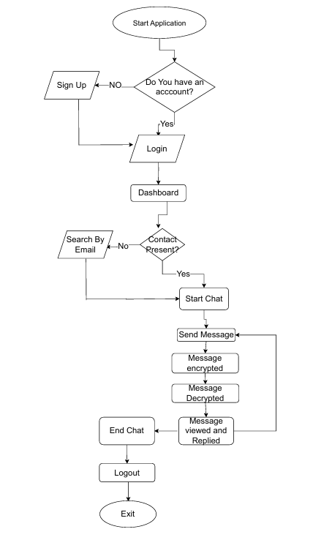

Fig 1- Monolithic Architecture for the application

7. Results

ChatCrypt with AES encryption ensures secure communication between users. During user registration, passwords are hashed using bcrypt and stored securely in a MongoDB database. When users send messages, the message content is encrypted using AES before being transmitted to the server. The server stores these encrypted messages in MongoDB and the receiver retrieves them via HTTPS GET requests. Upon receiving the encrypted messages, the receiver decrypts them using the same AES key, ensuring that only authorized users can access the message content. The application uses HTTPS POST/GET methods to simulate real-time communication, with periodic GET requests checking for new messages. This approach maintains security, as all messages are encrypted in transit and stored securely, and user authentication is handled by comparing hashed passwords with bcrypt. The MongoDB database provides scalability for storing chat histories and user data efficiently. Overall, the system ensures data confidentiality, integrity, and secure communication between users.

Interface :

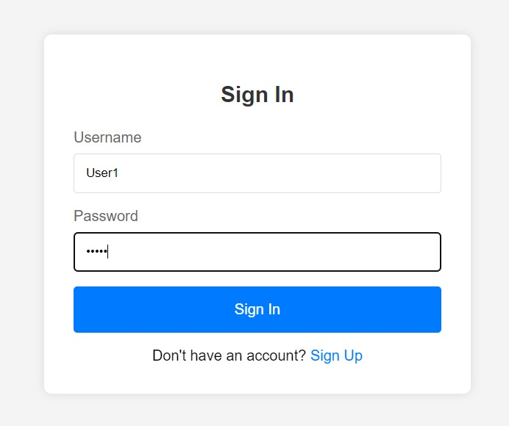

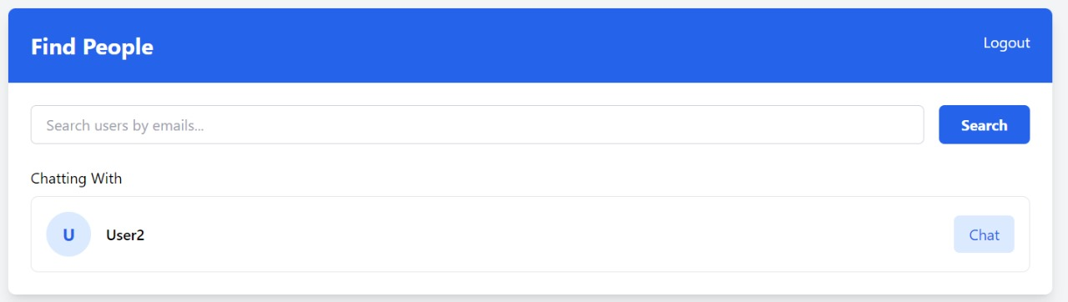
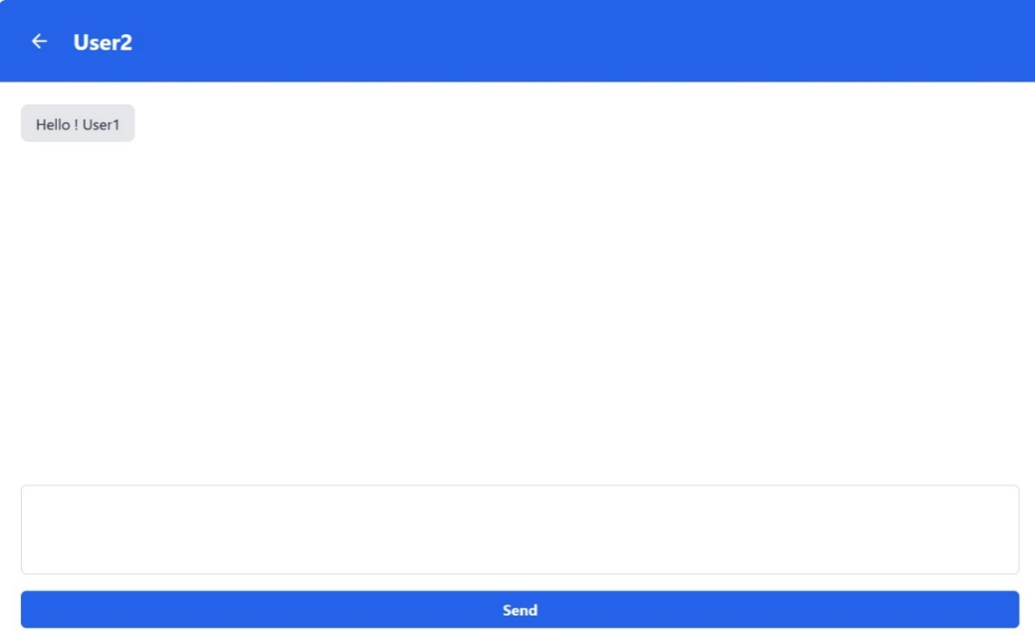
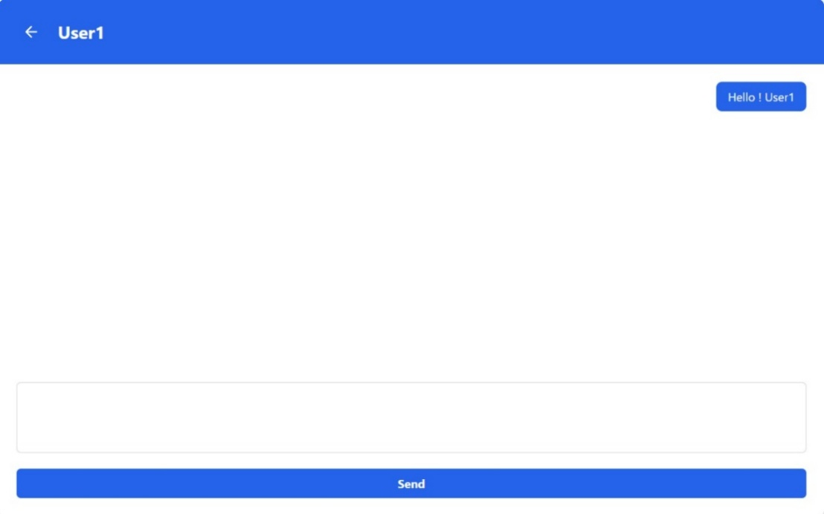
Database Entries :
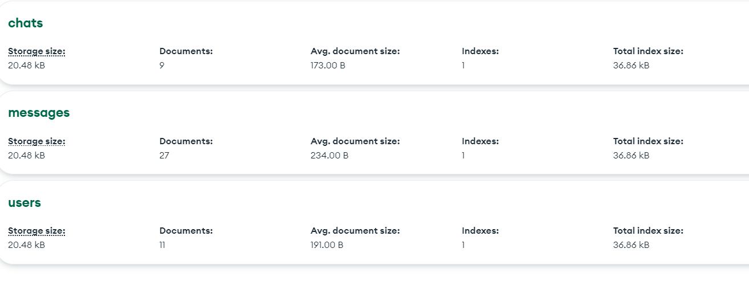

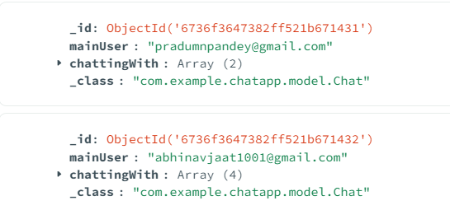
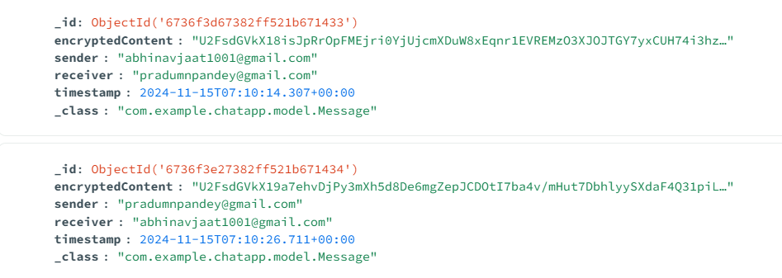

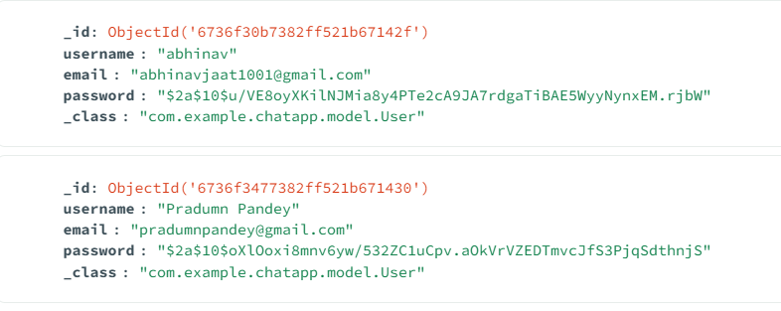

8. SWOT Analysis
Strengths:
- Advanced encryption ensures robust data protection.
- Responsive UI and real-time messaging enhance user satisfaction.
- Supports both individual and group communication, fostering collaboration.
Weaknesses:
- Initial user onboarding might be challenging due to technical complexity.
- Dependency on stable internet connections for optimal performance.
Opportunities:
- Potential for integration with AI-based chat assistants to improve interactivity.
- Expansion to mobile platforms for increased accessibility.
Threats:
- Emerging competitors with similar features.
- Risk of cyberattacks targeting user data despite encryption measures.

9. PERT Chart

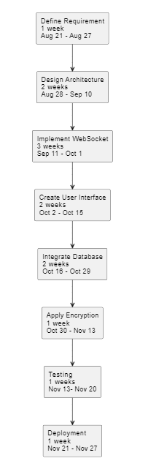

12. References
- Kumar, A., & Gupta, P. (2023, April). Development of Chat Application. In International Journal for Research in Applied Science & Engineering Technology (IJRASET). Retrieved from https://www.ijraset.com/research-paper/development-of-chat-application
- Bardis, N. G., & Ntaikos, K. (2008, October). Design of a secure chat application based on AES cryptographic algorithm and key management. In ResearchGate. Retrieved from https://www.researchgate.net/publication/234793505_Design_of_a_secure_chat_application_based_on_AES_cryptographic_algorithm_and_key_management
- Sharma, V., & Singh, A. (2023, March). A Study on Chat Application Design with Security Features. In International Journal of Advanced Research in Science, Communication, and Technology (IJARSCT). Retrieved from https://ijarsct.co.in/Paper10617.pdf
- Patel, R., & Roy, S. (2023, March). Design and Implementation of a Secure Chat Application. In International Journal of Creative Research Thoughts (IJCRT). Retrieved from https://ijcrt.org/papers/IJCRT2303722.pdf

